
Lab 02
Group : 07
Course Code : CSE209
Course Title : Electrical Circuits

Submitted To
Dr. Sarwar Jahan,
Associate Professor
Department of Computer Science and Engineering

Submitted By
Name : Sheikh Sarafat Hossain
Id No : 2022-3-60-109
Section : 01
Semester : Summer 24

Date of Submission: 14 July, 2024
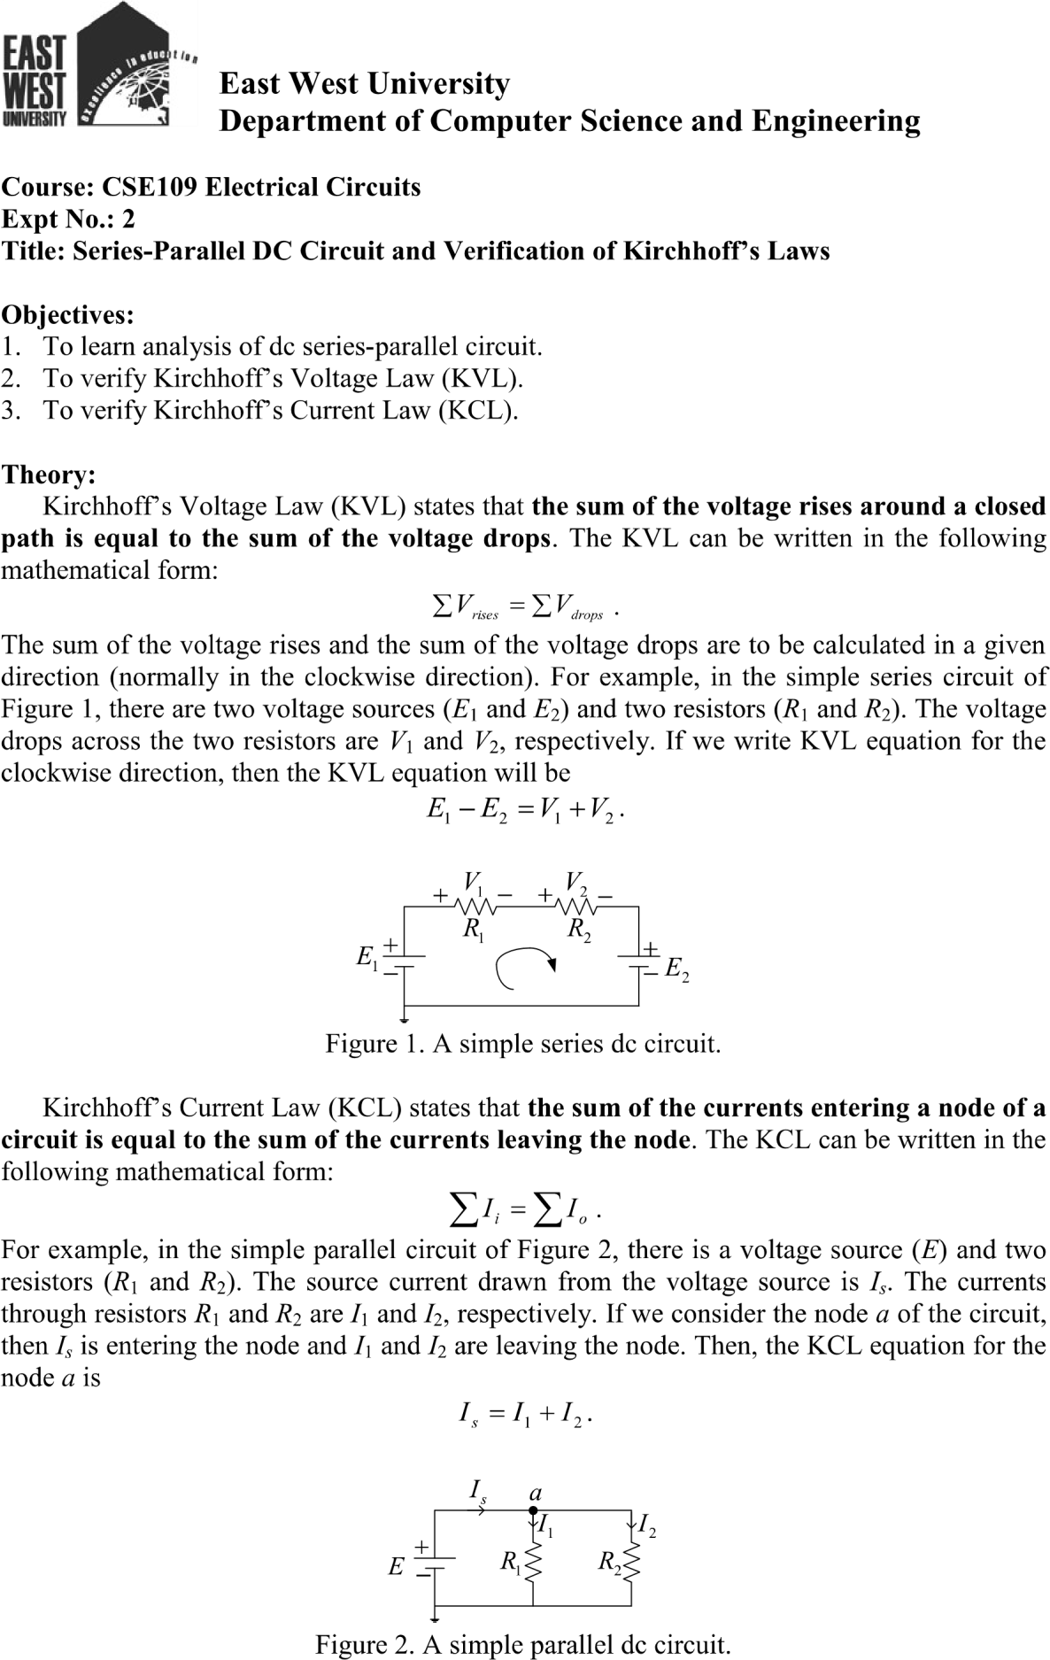

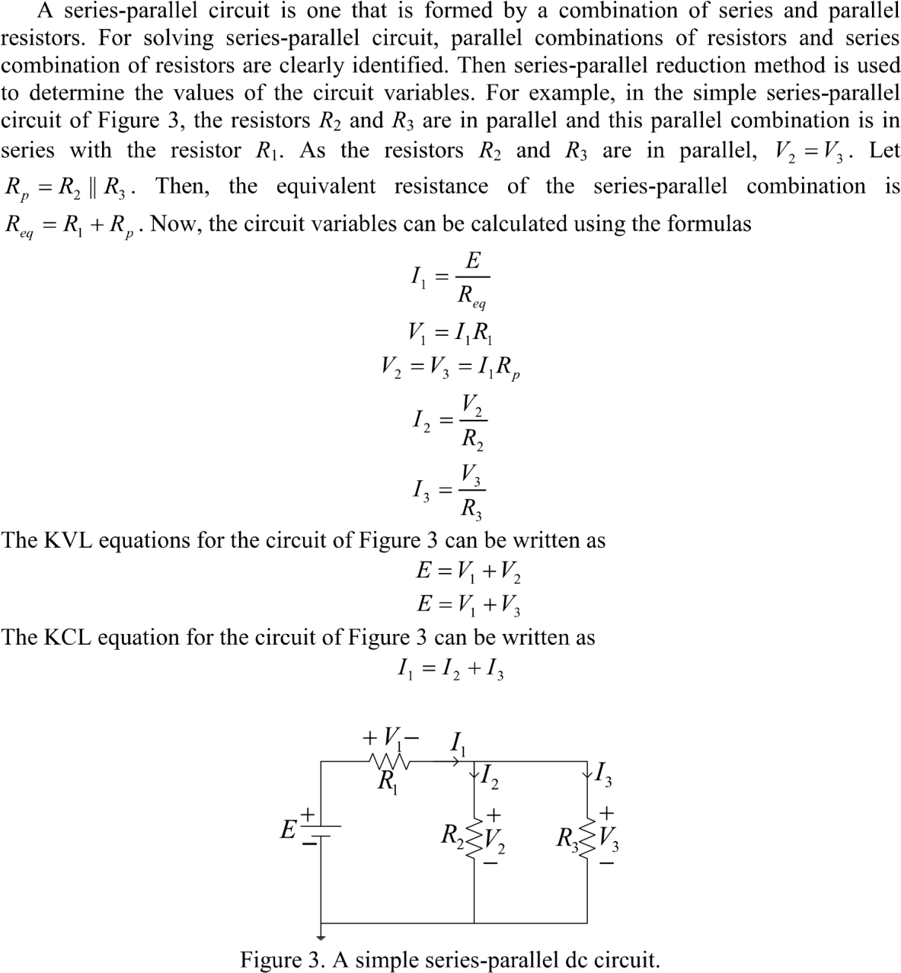

Pre – Lab Report :

1. Theoretical Calculations
Given:
R₁ = 1000 Ω
R₂ = 470 Ω
R₃= 1000 Ω
E = 3V

Finding Total Resistance
The resistors R₂ and R₃ are in parallel, so their equivalent resistance (R₂₃) can be calculated as:
1/R23 = 1/R2 + 1/R3
1/R23 = 1/470 +1/1000
R23 = (1/470 + 1/1000)-1

𝑹_{𝟐𝟑} ≈ 319 Ω
Now, 𝑹_{𝟐𝟑} is in series with 𝑹_{𝟏} :
𝑹𝒕𝒐𝒕𝒂𝒍 = 𝑹𝟏 + 𝑹𝟐𝟑
𝑹_{𝒕𝒐𝒕𝒂𝒍} = 𝟏𝟎𝟎𝟎 + 𝟑𝟏𝟗
𝑹_{𝒕𝒐𝒕𝒂𝒍} ≈ 1319 Ω

Finding Total Current ( I₁)
𝑬
I₁ =
𝑹𝒕𝒐𝒕𝒂𝒍

I₁ = 3 / 1319

I₁ ≈ 2,27 mA
Voltage across R₁ (V₁)
V₁ = I₁ . R₁
V₁ = 2,27 mA × 1000 Ω
V₁ ≈ 2.27 V
Voltage across R₂₃ (V₂₃)
V₂₃ = E – V₁
V₂₃ = 3V – 2.27V
V₂₃ ≈ 0.73 V
Current through R₂ (I₂)

I₂ = V23 / R2

I₂ = 0.73 / 470

I₂ ≈ 1.55 mA Current through R₃ (I₃)

I₃ = v23 / R3

I₃ = 0.73 / 1000

I₃ ≈ 0.73 mA
- Verifying KVL and KCL
KVL (Kirchhoff’s Voltage Law)
E =V₁ + V₂₃
3V = 2.27 V + 0.73 V
3V = 3V
KVL holds true.
KCL (Kirchhoff’s Current Law)
I₁ = I₂ +I₃
2.27mA = 1.55 mA +0.73mA
2.27 mA = 2.28mA
There is a slight rounding error, but KCL approximately holds true.
Equipments and Components Needed:
- DC power supply
- DC voltmeter
- DC ammeter
- Multimeter
- Resistor 1000 (two) and 470 (one)
- Breadboard
- Connecting wires Lab Procedure:
- Measure the resistance values of the resistors supplied and record them in Table 1.
- Construct the circuit of Figure 4. Set the value of E at 3 V. Measure the values of E. V₁, V₂, V₃, I₁, I₂ and I₃, and record them in Table 1.
- From experimental data, (i) show that V₂ = V₃ (ii) verify KVL, that is E =V₁ + V₂, and
(iii) verify KCL, that is I₁ = I₂ +I_{3.}

Table 1 Experimental Datasheet
Measured  Value of E (V) | Measured  Value of  V₁(V) | Measured  Value of  V₂(V) | Measured  Value of  V₃(V) | Measured  Value of  I₁ (mA) | Measured  Value of  I₂ (mA) | Measured  Value of  I₃ (mA) | Measured  Value of  Resistances  (Ω)
2.8 | 2.09 | 0.66 | 0.66 | 20 | 6 | 14 | R₁ = 0.10  R₂ = 0.047  R₃= 0.100

Post – Lab Report :

1. Theoretical Calculation
R₁ = 0.10 Ω
R₂ = 0.047 Ω
R₃= 0.100 Ω
E = 2.8 V

Finding Total Resistance
The resistors R₂ and R₃ are in parallel, so their equivalent resistance (R₂₃) can be calculated as:
1 / R23 = 1/R2 + 1/R3
1 / R23 = 1/ 0.047 + 1/ 0.0100

𝑹𝟐𝟑 = ( 1/0 - 1/ 0.047 + 1/ 0.100)
𝑹_{𝟐𝟑} ≈ 0.0319 Ω
Now, 𝑹_{𝟐𝟑} is in series with 𝑹_{𝟏} :
𝑹𝒕𝒐𝒕𝒂𝒍 = 𝑹𝟏 + 𝑹𝟐𝟑
𝑹_{𝒕𝒐𝒕𝒂𝒍} = 𝟎. 𝟏𝟎 + 𝟎. 𝟎𝟑𝟏𝟗
𝑹_{𝒕𝒐𝒕𝒂𝒍} ≈ 0.1319 Ω
Finding Total Current ( I₁)

I₁ = E / Rtotal

I1 = 28 /0.1319
I₁ ≈ 20 mA
Voltage across R₁ (V₁)
V₁ = I₁ x R₁
V₁ = 20 mA × 0.10 Ω
V₁ ≈ 2.09V
Voltage across R₂₃ (V₂₃)
V₂₃ = E – V₁
V₂₃ = 2.8V – 2.09V
V₂₃ ≈ 0.66 V
V₂ = V₃ = 0.66
Current through R₂ (I₂)

I₂ = v23/R2

I2 = 0.66/0.047
I₂ ≈ 6 mA
Current through R₃ (I₃)

I₃ = v23 / R3

I3 = 0.66 / 0.04
I₃ ≈ 14 mA
2. Verifying KVL and KCL
KVL (Kirchhoff’s Voltage Law)
E =V₁ + V₂₃
2.8V = 2.09 V + 0.66 V
2.8V = 2.75V
There is a slight rounding error , but KVL holds true.
KCL (Kirchhoff’s Current Law)
I₁ = I₂ +I₃
20mA = 6 mA +14 mA
20 mA = 20 mA
KCL approximately holds true.
